The Relationship of the Speed of Light to Aether Density
Jeff Yee
jeffsyee@gmail.com
February 8, 2020

Abstract: The speed at which sound travels is known to be related to the elasticity and density of the medium in which it propagates. The same principles of sound are applied to a universe with a substance, referred to as an aether, to describe the speed of light with the same equations that apply to sound.

1. Aether Density
In the Physics of Subatomic Particles and Their Behavior Modeled with Classical Laws paper, a density calculation of 4 x 10²² kg/m³ was found using two methods involving fundamental physical constants []. The values and units for all constants in this paper are found in the Appendix and are based on CODATA values [].
The first is based on the Planck mass (m_{P}), by dividing this mass by the volume of a sphere of hydrogen (radius of the Bohr radius - r_{h}) shown in Eq. 1.1. The second method is based on the magnetic constant (μ₀), by dividing it by the volume of a sphere of the electron (radius of the electron classical radius – r_{e}) shown in Eq. 1.2. Section 2 explains the linear density of the magnetic constant, its units and why re² appears in the denominator instead of re³.
(1.1)
(1.2)
The first equation is based on hydrogen (an atom), while the second is based on the electron (a particle). A third equation is now introduced that is derived from the Planck constant (h), which is used when calculating energies of photons. Thus, atoms, particles and photons may all interact in a medium with the same density value. This is referred to here as the density of the aether.
(1.3)
In the same paper, the energies of hydrogen and the electron were found to be proportional to the Planck energy (Planck mass times speed of light squared), based on radius, where the radius of the particle or atom is a ratio relative to the Planck length (l_{P}). A visual of this is shown in Fig. 1.
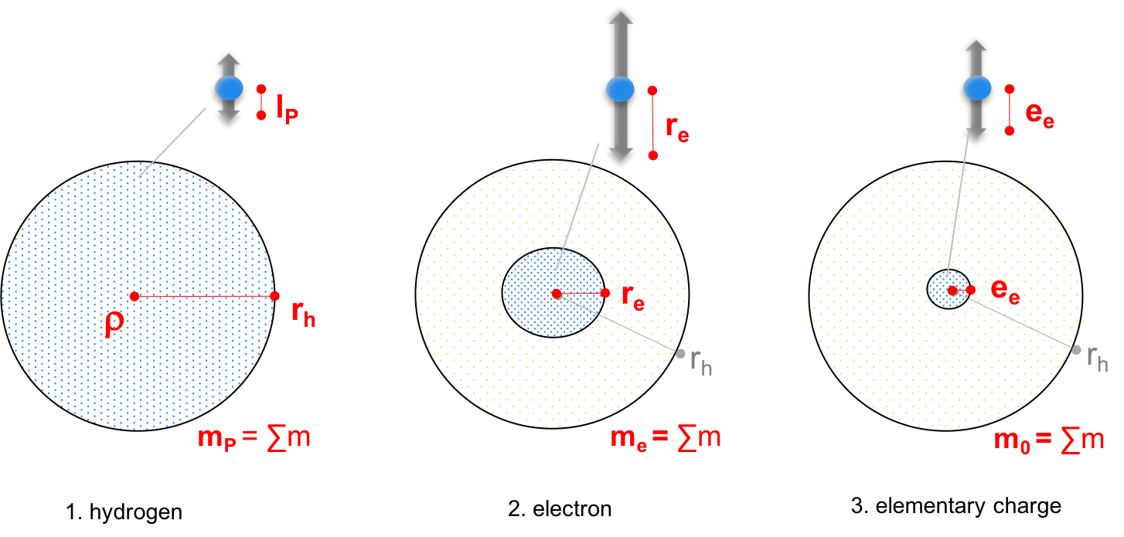
Fig. 1 – Motion of aether “granules” at three radii: hydrogen, electron and elementary charge
A third distance is added in Fig. 1 to represent the harmonic motion creating wave patterns in particles and photons (#3 in Fig. 1 – elementary charge). These three volumes, and their representative mass (the sum of the masses in the volume), will be used in the next sections.

2. Linear Density and the Magnetic Constant
The motion of an incredible number of aether granules in Fig. 1 is difficult to calculate but it can be simplified to a representative mass and its displacement over time (velocity). For example, the sum of all granules from Fig. 1 (hydrogen) is replaced by a mass of Planck mass, traveling a Planck length in time (t). This is illustrated in Fig. 2 before an elastic collision with another mass (with electron mass – m_{e}). After the collision, the smaller mass is displaced an electron radius in the same time.
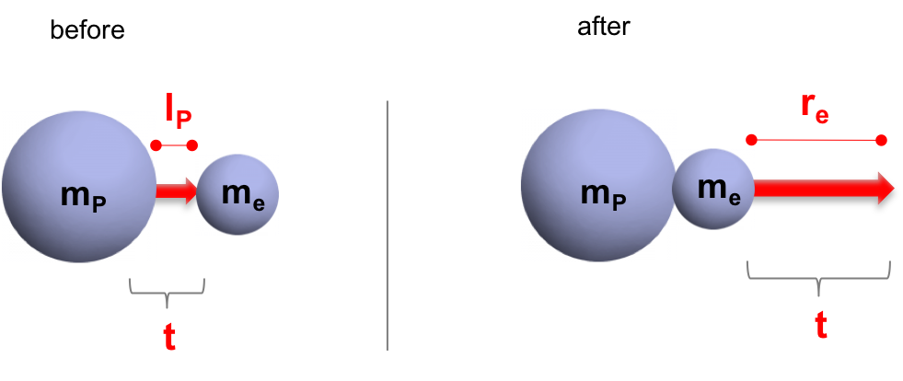
Fig. 2 – Planck mass and electron mass – conservation of momentum
It can be calculated using the conservation of momentum, where the mass times velocity of the first object (m₁ and v₁) is equal to the mass times velocity of the second object (m₂ and v₂).
(2.1)
The first mass is a modified Planck mass and fine structure constant (α_{e}), consistent with the findings in the Physics of Subatomic Particles paper. The second mass is the electron.
(2.2)
(2.3)
Also consistent with the paper is the radius for these masses at Planck length and the electron radius. Here in this paper, these radii are calculated as displacement distances over the same time (t₀), becoming a velocity. Eq. 2.4 is the displacement of Planck length over the same time as the electron radius (Eq. 2.5).
(2.4)
(2.5)
Substituting values from Eqs. 2.2 to 2.5 into Eq. 2.1, shows that the conservation of momentum is indeed correct as both sides of the equation yield a value of 2.57 x 10⁻⁴⁵.
(2.6)
The same conservation of momentum is now applied to a representative mass called m₀, which represents the sum of the granule masses described in the length of the elementary charge (e_{e}), shown visually in Fig. 1. A before and after view of this mass (m₀) in an elastic collision with the electron is shown in Fig. 3.
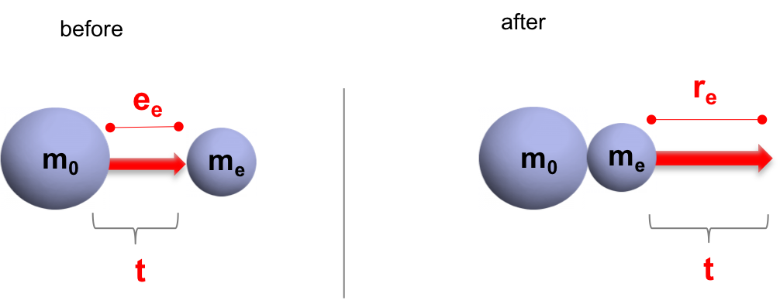
Fig. 3 – Elementary charge mass and electron mass – conservation of momentum
Once again, the conservation of momentum is applied where m₀v₀=m_{e}v_{e}, and the displacement distance for the first mass is the elementary charge (e_{e}) distance.
(2.7)
(2.8)
Eq. 2.8 arrives at a mass of a representative particle in the length of the elementary charge. This distance is chosen because harmonic motion leads to the creation of wave patterns, and the elementary charge is proposed to be the peak-to-peak displacement of granules in an electron (i.e. within one wavelength).
The single “representative” mass is now replaced by individual masses within this one-dimensional length (e_{e}) in Fig. 4, where the sum of the individual masses would be the representative mass. It is illustrated like a string of masses, similar to Newton’s cradle, because it will be used in the next section for the calculation of wave speed.
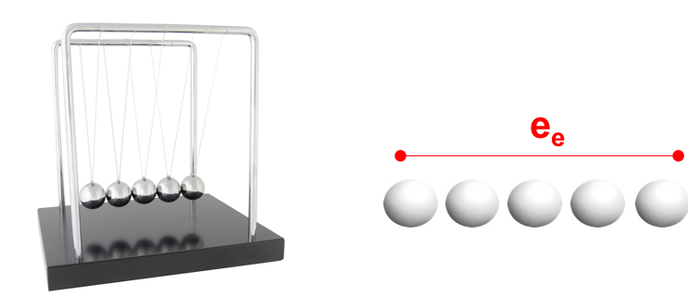
Fig. 4 – Newton’s cradle and a string of masses
A one-dimensional, linear density (μ) is calculated as mass divided by length. In this case, it is m₀ divided by the elementary charge (e_{e}) length. Eq. 2.8 is substituted for mass m₀ and solved.
(2.9)
The linear density is given the sub-notation “m” for magnetism. It may be recognized that this value is the magnetic constant (μ₀) divided by 4π. This value, μ_{m}, better represents the point particle form of magnetism found in Robert Distinti’s New Magnetism []. Distinti refers to the value as k_{m}, but it is referred to here as μ_{m} to be consistent with a constant representing linear density. The following are all equivalent.
(2.10)
To prove that the magnetic constant is indeed a linear density, recall that elementary charge (e_{e}) is described as displacement, which is measured in SI units as meters (m). Thus, Coulombs (C) is replaced with meters (m) when units are derived. The following is the derivation of the magnetic constant beginning with henries (H) per meter, then replacing the henry with its equivalent SI units, then replacing Coulombs with meters. It results in kilograms per meter which is a linear density.
(2.11)

3. Newton’s Cradle and the Speed of Sound
In the previous Fig. 4, Newton’s cradle is illustrated as a string of masses. This example is used to show a linear density, but also because it can be easily visualized and calculated with classical physics.
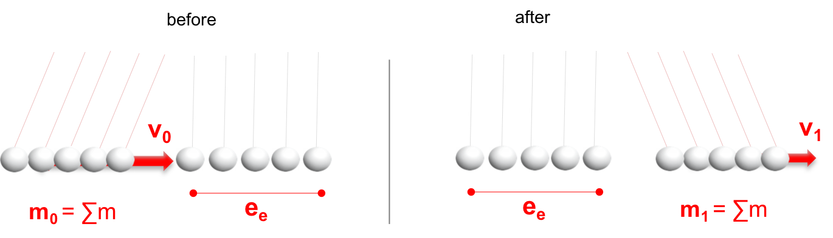
Fig. 5 – Newton’s cradle before and after with masses m₀, m₁ and velocities v₀, v₁
Using the conservation of energy for an elastic collision, the kinetic energy before and after will be equal.
(3.1)
Velocity can be solved from the previous equation as:
(3.2)
Although these masses (m₀ and m₁) are not known, a simple algebra trick allows the numerator and denominator to be modified to be two constants that are known. Both the numerator and denominator in the square root are multiplied by a distance r.
(3.3)
The numerator divided by r is a force (F). Meanwhile the denominator divided by r is a linear density. This is expressed in the next two equations.
(3.4)
(3.5)
After substituting Eqs. 3.4 and 3.5 into Eq. 3.3, velocity is solved as the square root of the force divided by linear density. This is the equation for the speed of sound in a string (one-dimensional) []. Note that the speed of sound in three dimensions is a variation of this, which is force over a cross section divided by three-dimensional density.
(3.6)
(3.7)

4. The Speed of Light
The same equation for the speed of sound (Eq. 3.7) can be applied to the speed of light. The two are related, as they travel in the same space, yet with different velocities. Sound is the vibration of particles with mass. Light is proposed to be the vibration of the physical substance that creates such particles – granules in the aether. Newton’s cradle is shown again as the force (F) on a linear density (μ).
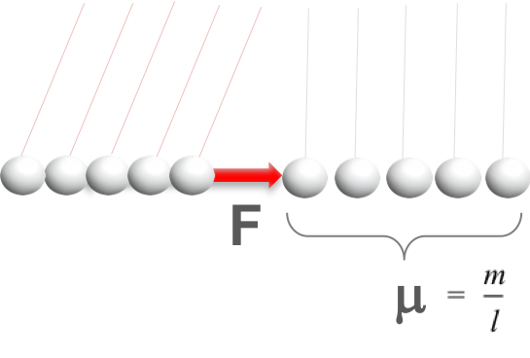
Fig. 6 – The force (F) of Newton’s Cradle on a string of masses (m) over a length (l)
These constants for force and linear density are known as they appear in equations that model the behavior of electricity and magnetism. They are Coulomb’s constant (k_{e}) and the modified magnetic constant (μ_{m}). The latter is the magnetic constant divided by 4π.
(4.1)
The elementary charge was used earlier as displacement because it represents the masses in a wavelength. It was then used for the derivation of the magnetic constant. Using Coulomb’s Law, when the distance r=e_{e}, the force equation resolves to be the constant itself – k_{e}. Note for single particles, q is the elementary charge.
(4.2)
To prove that the Coulomb constant is truly a force (kg*m/s²) the derivation of units is shown for k_{e}. Once again, units of Coulombs (C) is replaced with meters (m). The units derive correctly to be a force.
(4.3)
James Maxwell found this force and linear density in his equations, although it was not realized that either were truly a force and density because of the misunderstanding of the meaning of charge and its units. Maxwell used the electric constant (ε₀) and magnetic constant (μ₀) []. The electric constant is the inverse of the Coulomb constant and applies 4π (Eq. 4.4), so the 4π is added back to the modified version of the magnetic constant (Eq. 4.5) to be consistent. The 4π could be applied to either – it may be a matter of preference – but the modified version of the magnetic constant is used here because it works well with Distinti’s point particle form of magnetism.
(4.4)
(4.5)
The constants k_{e} and μ_{m} from Eq. 4.1 are replaced with the electric constant (Eq. 4.4) and magnetic constant (Eq. 4.5). Solving either Eq. 4.1 or Eq. 4.6 results in the calculation of the speed of light (c). Highlighted in red is what Maxwell found to determine this speed.
(4.6)

Conclusion
The harmonic motion of something that occupies space, referred to here as granules in the aether, can be calculated for the speed at which the collective vibrations of the masses travel. The speed of light can be calculated based on two properties that are found naturally in electrical and magnetic experiments, which is why they were given the names for the electric (ε₀) and magnetic constants (μ₀). However, a better understanding of charge and its units shows that the electric constant is a force and the magnetic constant is a linear density. This understanding allows the wave speed for light to be linked to the wave speed for sound with the same equation.
The linear density of space is known as the magnetic constant because it is derived as a force between two particles (one-dimension). This linear density can be converted to a three-dimensional density property using an electron’s sphere and was shown to be an extremely dense 4 x 10²² kg/m³ in Section 1. In addition to finding this density property using the electron particle, two different methods using an atom (hydrogen) and a photon (using Planck’s constant – h) resulted in the same density of 4 x 10²² kg/m³.
To explain this high density, the concept of mass may need to be revised to include two types: kinetic and stored. Particles are likely stored energy as standing waves with no net propagation of energy – therefore stored mass. Within particles and between particles is kinetic mass. When all the mass within hydrogen collapses and is stored, it becomes the Planck mass. When part of the mass is stored, it becomes particles like the electron. As the granules of the aether vibrate (kinetic mass), the speed at which they travel is the speed of light. As particles of stored mass vibrate, the speed that it travels is the speed of sound, which is variable based on the mass and placement of such particles. Yet the equations are the same, linking wave speed to density.

Appendix
Constants
The following constants are used in this paper (CODATA values).
Symbol | Definition | Value (units)
c | Wave velocity (speed of light) | 299,792,458 (m/s)
m_{P} | Planck mass | 2.1765 x 10⁻⁸ (kg)
k_{e} | Coulomb constant | 8.9876 x 10⁹ (kg*m/s²)ª
μ₀ | Magnetic constant | 1.2566 x 10⁻⁶ (kg/m)ª
ε₀ | Electric constant | 8.8542 x 10⁻¹² (s²/kg*m) ª
h | Planck constant | 6.6261 x 10⁻³⁴ (kg*m²/s)
q_{P} | Planck charge | 1.8756 x 10⁻¹⁸ (m)ª
e_{e} | Elementary charge | 1.6022 x 10⁻¹⁹ (m)ª
α_{e} | Fine structure constant | 0.00729735
l_{P} | Planck length | 1.6162 x 10⁻³⁵ (m)
r_{e} | Electron classical radius | 2.8179 x 10⁻¹⁵ (m)
r_{h} | Hydrogen 1s radius (Bohr radius – a₀) | 5.2918 x 10⁻¹¹ (m)
ª – Corrected units when units of Coulombs (C) is replaced with distance (meters).

Yee, J., Gardi, L., 2020. The Physics of Subatomic Particles and Their Behavior Modeled with Classical Laws. ResearchGate. Online: https://www.researchgate.net/publication/338634046.
Mohr, P., Newell, D. and Taylor, B., 2014. CODATA Recommended Values of the Fundamental Physical Constants, Rev. Mod. Phys. 88, 035009.
Distinti, R., 2020. New Magnetism, Online: http://www.distinti.com/docs/nm.pdf.
PSCC, 2020. Sound. Online: http://www.pstcc.edu/nbs/WebPhysics/Chapter017.htm.
Wikipedia, 2020. Maxwell’s Equations. Online: https://en.wikipedia.org/wiki/Maxwell%27s_equations.

